Ewalt Volschenk

Week 6: practical

Task 1: Security Posture Assessment
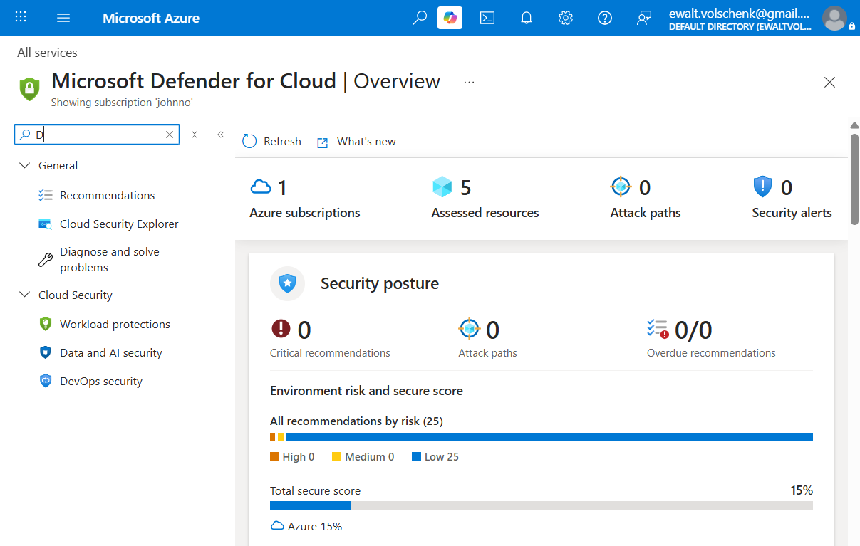
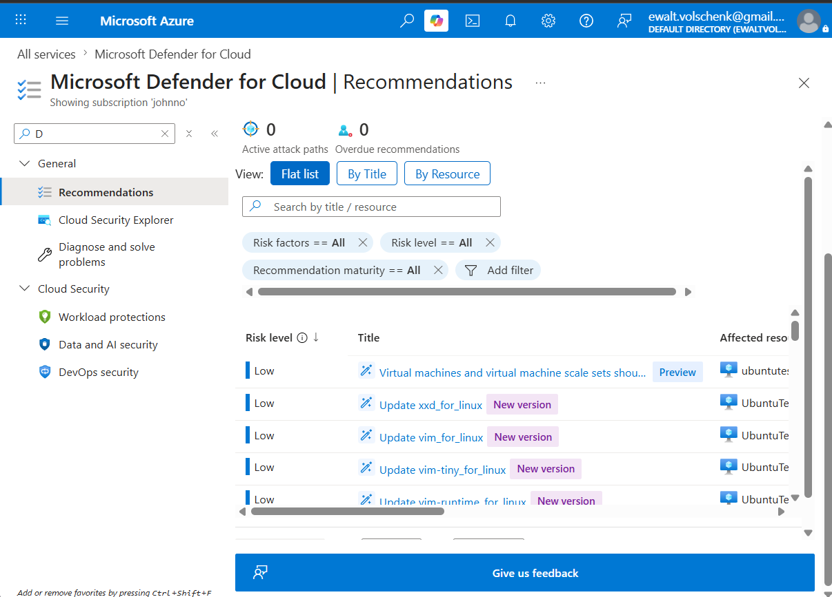

Task 2a
Although the recommendation did not appear in Microsoft Defender for Cloud as of yet, it may just be awaiting assessment since Azure performs vulnerability scans based on resource type. This means that updates can occur any time between 30 minutes and 24 hours. The vulnerability is however evident in the NSG.

Before:
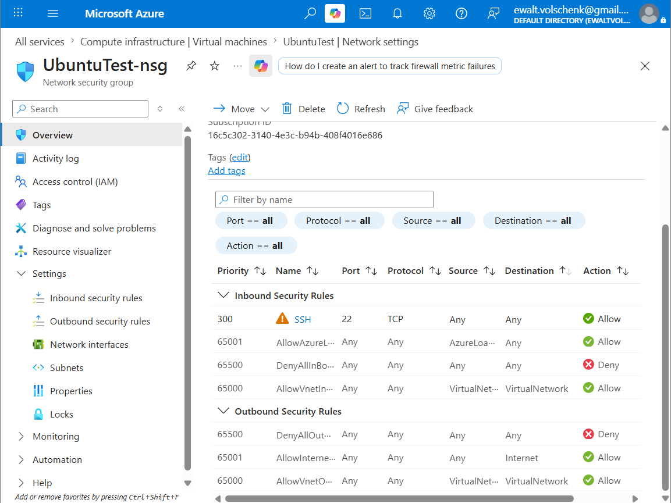

After:
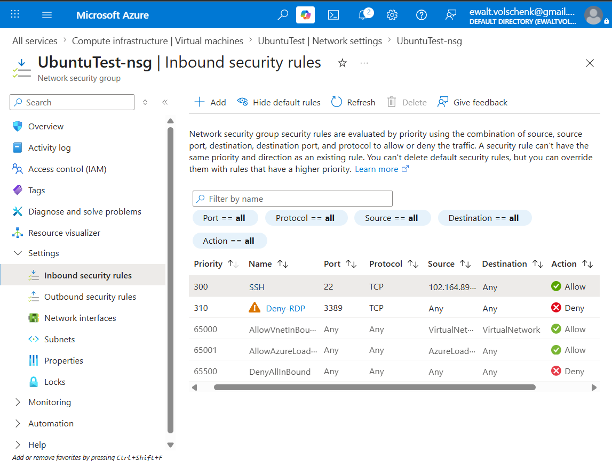
I changed the SSH rules to only accept my IP address as a source for SSH and I created an Inbound rule to Deny all RDP traffic.

TASK 2b
Before:
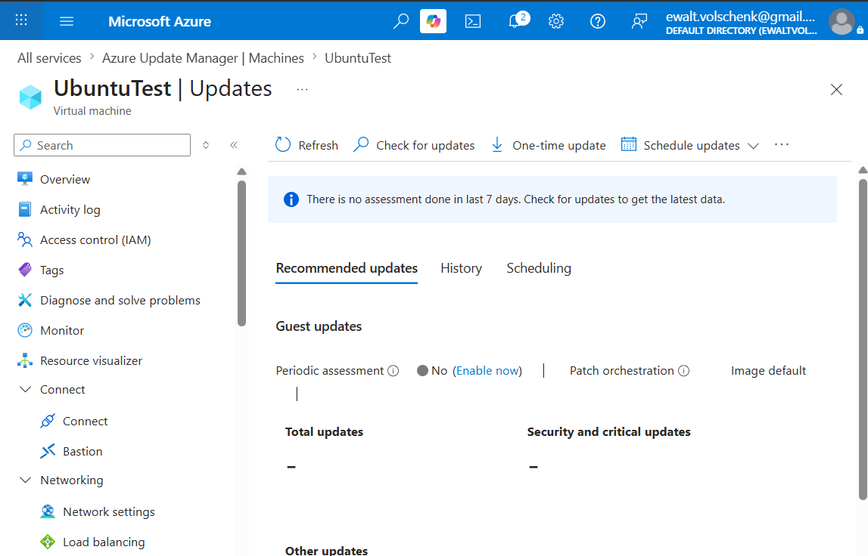
After:
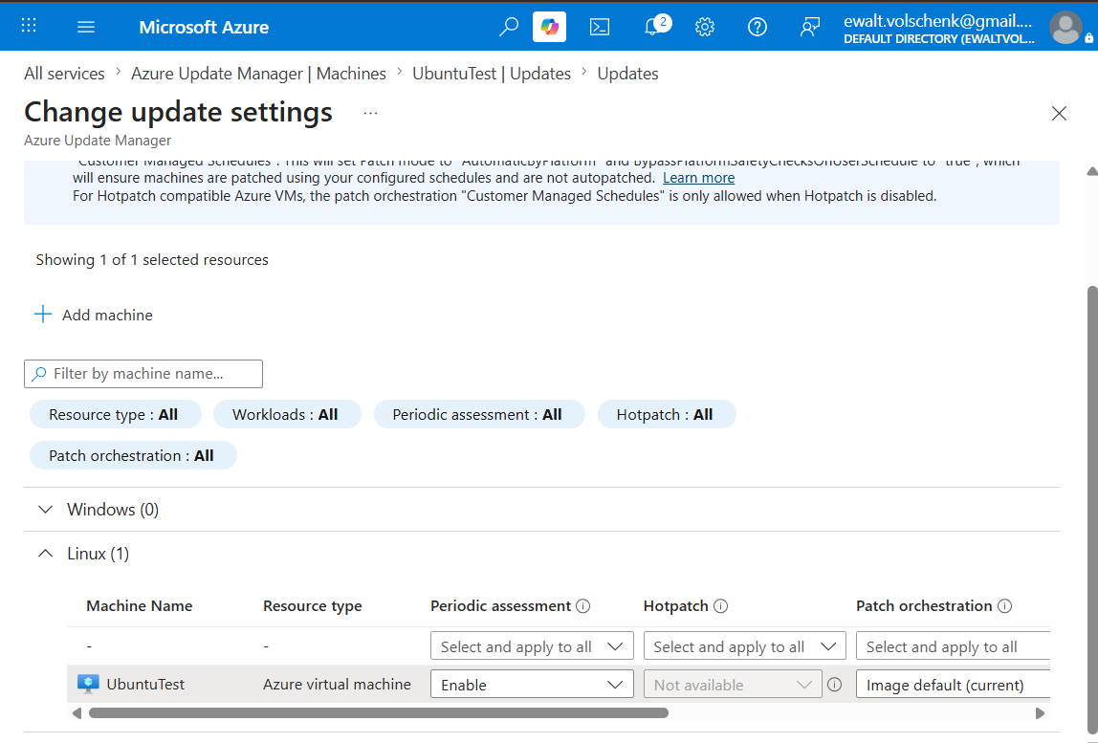

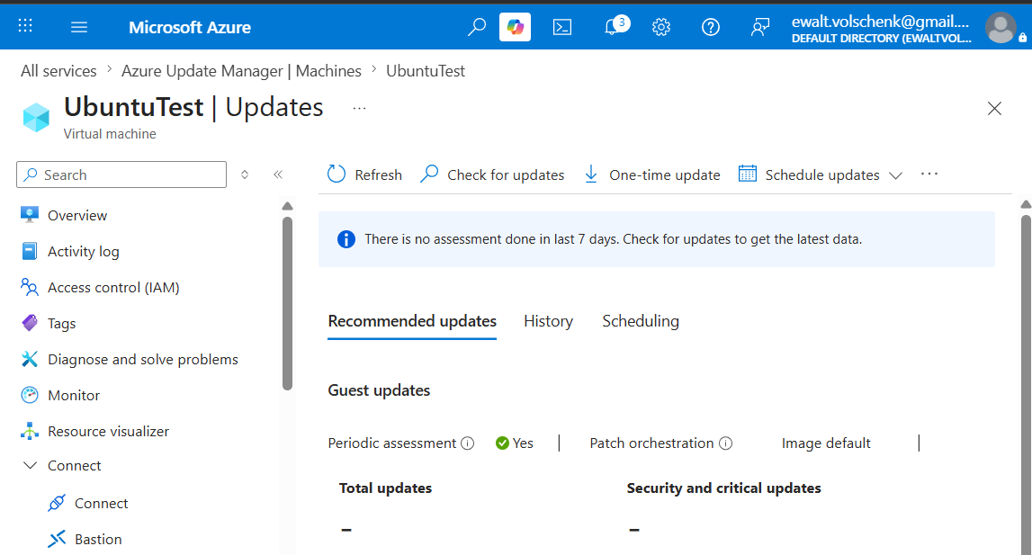

README:
What I found is that Defender for cloud does incremental scans to detect vulnerabilities and that depending on resource types these scans can take place between 30 minutes and 24 hours. Although Defender for Cloud did not show the SSH and RDP vulnerabilities I did manage to remedy them by modifying an existing inbound NSG rule to only allow the source destination for SSH to be my IP address. I created another inbound NSG rule to deny all RDP traffic from all sources effectively disabling RDP as a whole, only allowing SSH traffic from my device. Additionally I enabled Automatic Perdiodic assessment to automatically scan for updates every 24 hours

